Multiple Choice – Identify the choice that best completes the statement or answers the question.

_____ 1.) Four bags of potatoes weigh 3.35 pounds, 4.894 pounds, 5.6 pounds, and 4.95 pounds.
What is the total weight of the bags?
A. 187.94 pounds B. 1.8794 pounds

C. 18.794 pounds D. 20.62 pounds

_____ 2.) If you multiply $3.3×0.02$, how many times would you move the decimal?
A. $1$ B. $2$

C. $3$ D. $4$

_____ 3.) You are on a 6.6 mile run and have already run 1.96 miles. How many more miles do you need to run?
A. $5$ miles B. $4.64$ miles

C. $8.56$ miles D. $4.76$ miles
Find each sum. Show ALL work!
4.) $8.21+13.6$= 5.) $6.5 +7.63 +1.437$=

Find each difference. Show ALL work!
6.) $63.69-13.592$= 7.) $24.56-6.13$=

Find each product. Show ALL work!
8.) $6.4 × 0.03$= 9.) $4.17 × 1.5$=

Find each quotient. Show ALL work!
10.) 974 ÷ 18= 11.) 4,697 ÷ 7=

12.) 6.8 ÷ 2= 13.) 97.5 ÷ 6=

14.) 3827 ÷ 4.3= 15.) 2.35 ÷ 0.141=

Problem Solving – Read the following problems carefully! You must show ALL your work!
16.) A deli charges $5.40 for a pound of ham.
a.) If Evan wants to purchase 3.2 pounds, how much will it cost?

b.) How much change would Evan receive if he paid with a $20 bill?

Error Analysis – Identify the error. What is the correct quotient?
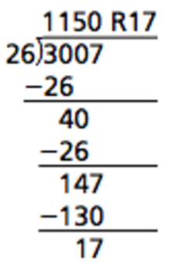
17.) Explain error:

What is the correct quotient?

